BREAST CANCER CLASSIFICATION FROM HISTOPATHOLOGY IMAGES USING CNN WITH ATTENTION MECHANISMS

BY

IWANEFUN OLUWATIMILEHIN INIOLUWA
(2020/9843)

A PROJECT SUBMITTED TO THE DEPARTMENT OF COMPUTER ENGINEERING, COLLEGE OF ENGINEERING, BELLS UNIVERSITY OF
TECHNOLOGY, OTA IN PARTIAL FULFILLMENT OF THE REQUIREMENTS FOR THE AWARD OF BACHELOR OF ENGINEERING
JULY, 2025.
SUPERVISED BY ENGR. S.A BABATUNDE

DECLARATION
I hereby declare that this project, titled "BREAST CANCER CLASSIFICATION FROM HISTOPATHOLOGY IMAGES USING CNN WITH ATTENTION MECHANISM" is my original work and has been conducted independently. All sources of information and data that have been used or quoted in this dissertation have been fully acknowledged and referenced.
This dissertation has not been previously submitted, in whole or in part, for the award of any degree or diploma at any other institution or university. Any assistance that has been received during the research process has been appropriately credited.
I understand the implications of academic dishonesty and affirm that this work adheres to the ethical guidelines and standards set forth by the institution

IWANEFUN OLUWATIMILEHIN INIOLUWA ……………….. ………..…….....
Author Signature Date

CERTIFICATION
This is to certify that this project report on the “BREAST CANCER CLASSIFICATION FROM HISTOPATHOLOGY IMAGES USING CNN WITH ATTENTION MECHANISM” submitted to the Department of Computer Engineering, Bells University of Technology, Ota, Ogun State for the award of the degree of Bachelor of Engineering is a record of original research carried out by IWANEFUN OLUWATIMILEHIN INIOLUWA.

ENGR. S.A BABATUNDE …………………….. …………………
Supervisor Signature Date

ENGR A.W. ELEGBEDE …………………… …………………
Head of Department Signature Date

DR. ………………….. …………..…….
External Supervisor Signature Date

DEDICATION
This report is dedicated to God, for his grace throughout my training, to my family for their support towards my education and to the whole staffs in Bells University of Technology for the invaluable knowledge I gained through them.

ACKNOWLEDGEMENTS
I truly appreciate the Lord of Hosts, in whom nothing is too difficult to accomplish for being a safeguard for me, my magnificence and the lifter of my head all through my stay at Bells University of technology, Ota and in particular during this research period.
My project supervisor, Engr. S.A Babatunde, has my sincere gratitude for seeing this research project through to completion. In a similar vein, I would like to express my sincere gratitude to my colleagues for their invaluable advice and assistance during the project's preparation. I would like to express my gratitude to the other lecturers who work in the Department of Computer Engineering for their enthusiastic support and commitment during my time at the university.
My immense gratitude goes to my wonderful parents; Mr and Mrs. Iwanefun and my siblings who assisted me until the completion of this project and also their encouragement throughout my study.
My earnest thanks and appreciation go to Dr. Orukotan who upheld me all through my tutoring period

ABSTRACT
Breast cancer remains as a leading cause of cancer death among women across the whole world with histopathological analysis of image being main in the diagnosis of cancer. Most of the literature that applied Convolutional Neural Networks (CNN) to problems related to classification reports an adequate accuracy in their results, but the problem with these methods is that the interpretability of the results under consideration, the computational cost is quite high. In this project, we concluded that it was necessary to create a clear and efficient deep learning model that can be used to classify breast cancer based on histopathological images. The approach was the application of the BreakHis dataset that worked comprising 7,909 images that were in four magnification depths. Preprocessing involved resizing of the images, normalization of the images, augmentation of the images and encoding of the binary labels. A ConvNeXt model with a Squeeze-and-Excitation (SE) attention mechanism is constructed and the model was trained in a five epoch configuration and batch sizes of 16. Accuracy, precision, recall, F1-score and AUC-ROC were used to evaluate the model. The accuracy and F1 score of which was seen to be high as the proposed ConvNeXt+SE model produced an accuracy result above 99 and F1-score above 99. Such findings reveal that the application of attention-enhanced CNNs has a significant potential to enhance the identification of malignancy in histopathology images, which could become an emergent solution towards accelerating, ensuring diagnostic certainty and affordability of breast cancers.

TABLE OF CONTENT

DECLARATION ii
CERTIFICATION iii
DEDICATION iv
ACKNOWLEDGEMENTS v
ABSTRACT vi
TABLE OF CONTENT vii
LIST OF TABLES ix
LIST OF FIGURES x
CHAPTER ONE 1
1.1 Background 1
1.2 Problem statement 2
1.3 Aim and objectives 3
1.3.1Aim 3
1.3.2 Objectives 3
1.4 Significance 3
1.5 Scope of study 4
CHAPTER TWO 5
2.1 Breast Cancer Diagnosis: Medical and Technological Background 5
2.2 Histopathology Imaging in Breast Cancer 8
2.3 Deep Learning in Medical Imaging 11
2.4 Transfer Learning in Breast Cancer Classification 14
2.5 Attention Mechanisms in CNN Models 17
2.6 Existing Approaches to Breast Cancer Classification 20
2.7 Summary of Gaps in Existing Literature 24
2.8 Related works 28
CHAPTER THREE 33
3.1 Research Design 33
3.3 Methodology 34
3.3.1 Data Collection 34
3.3.1.1 Details of BreakHis dataset 34
3.3.2 Data Preprocessing 34
3.3.3 Model Development 35
3.3.4 Training, Validation, and Testing 35
3.3.5 Model Performance Evaluation 36
CHAPTER FOUR 38
4.2 Training and Validation Results 38
4.3 Evaluation on the Test Set 39
4.3.1 Classification Report. 40
4.3.2 Confusion Matrix 40
4.5 Comparative Analysis of Performance and Methodology 43
CHAPTER FIVE 44
5.1 Conclusion 44
5.3 Recommendations 44
REFERENCES 46
APPENDIX 48

LIST OF TABLES
Table 2. 1 Show related works, methodology and critics 40

Table 4. 1 Summary of Model Training Parameters 45
Table 4. 2 Classification Report of the ConvNeXt + SE Model 47
Table 4. 3 Comparative Evaluation with Verified Authors 50

LIST OF FIGURES
Figure 2. 1 Examples of histopathology images in different level of magnification gotten from BreakHis Dataset. 10

Figure 3. 1 Block diagram representing the methodology used in completing the project 41

Figure 4. 1 Accuracy loss plot for ConvNeXt + SE 47
Figure 4. 2 Confusion Matrix of Test Set Predictions 48
Figure 4. 3 Grad-CAM attention heat map for a correctly classified benign sample. 50
Figure 4. 4 Grad-CAM attention heat map for a correctly classified malignant sample. 50

CHAPTER ONE
INTRODUCTION

1.1 Background
During 2020, breast cancer was by far the top cancer among women, causing about 2.3 million instances and 685,000 deaths (Sung et al., 2021). The year 2020 saw 281,550 women in America receive a breast cancer diagnosis and 43,600 related deaths (Siegel et al., 2020). Even though screening offers many more cancer diagnoses in wealthy countries, the fewer tests in low-income areas lead to greater cancer deaths (Sung et al., 2021).
Early diagnosis of breast cancer matters a lot, as the survival rate is still very high greater than the rates seen for breast cancer found later (Siegel et al., 2020). Even though clinical exams, mammography and histopathology are commonly used, all have their limitations (Litjens et al., 2020). Many women may not find mammography helpful, because it can sometimes give false-negative results when women’s breasts are dense (Chen et al., 2020). Histopathology is often not accurate or easy to perform and can only confirm cases of malignancy after tissue analysis; therefore, new automated equipment is becoming necessary (Krithiga and Geetha, 2022).
Special medical imaging advances are gotten thanks to deep learning, especially convolutional neural networks, as they automate analysis with a high degree of accuracy (Alzubaidi et al., 2021). BreakHis images from histopathology can be classified accurately by CNNs, showing accuracies over 90% (Hamza et al., 2022). They support mammography because they can spot subtleties and help avoid mistakes during diagnosis (Al-Jabbar et al., 2023). By training on pre-built ResNet models, transfer learning deals with not enough data by learning from features found in famous large-scale datasets such as ImageNet (Houssein et al., 2022).
The addition of Squeeze-and-Excitation blocks in VGG encouraging the model to pay better attention to important areas, raising both its effectiveness and how well it can be understood (Sitaula and Hossain, 2022). Thanks to these techniques, it is possible to produce robust classifications with only little data (Sebai et al., 2023). Even though deep learning can strengthen the medical profession by supporting clinicians and cutting down false positives, computing problems and understanding difficulties have yet to be fully solved (Murtaza et al., 2022).
It is clear from the lack of access to diagnosis in many low-income regions that we need new approaches that are fast and economical (Sung et al., 2021). Dealing with these issues can help deep learning improve the early recognition and outlook of breast cancer for all patients (Alzubaidi et al., 2021).

1.2 Problem statement
Traditional methods make it hard to diagnose breast cancer, which is becoming more common around the world (Sung et al., 2021). It is often difficult for mammography to detect breast cancer in dense breasts, causing some cancer cases to be missed and delaying early discovery (Chen et al., 2020). For sure malignancy, histopathology is very involved and can lead to different outcomes in exams, reducing the certainty of diagnosis (Krithiga and Geetha, 2022). Convolution neural networks make deep learning useful for automating breast cancer classification, especially since they achieve high results on the BreakHis dataset (Hamza et al. 2022).
Even so, there are major obstacles holding back the use of deep learning in clinical settings (Sebai et al., 2023). Because of their small size and lack of patient variety, BreakHis and DDSM limit how well models can be used across different patients and situations (Murtaza et al., 2022). Since ResNet and InceptionV3 are complex, they are difficult to use in places that have few financial resources and limited equipment for diagnosis (Houssein et al., 2022). Many clinicians mistrust CNNs, seen as hard to interpret which seriously affects the process of getting approval (Sitaula and Hossain, 2022). Because standardized datasets are frequently used in studies, there is little real world testing which prevents clinicians from using these methods (Sebai et al., 2020).

1.3 Aim and objectives
1.3.1Aim
To develop an efficient, interpretable deep learning model for automated breast cancer classification using histopathological images, enhancing diagnostic accuracy and accessibility.

Objectives
- To obtain and pre-process a high-quality dataset of breast cancer histopathology images,
- To train a CNN model(ConvNeXt) for binary classification(benign vs. malignant),
- To incorporate attention modules (Squeeze and Excitation) into the CNN architecture,
- To evaluate the model’s performance using accuracy, precision, Recall, F1-score, AUC-ROC,
- To visualize model focus areas using tools like Grad-CAM and attention heatmaps.

1.4 Significance
Deep learning could play a major role in addressing breast cancer, as each year, it causes disease for 2.3 million women (Sung et al., 2021). With more accurate diagnosis thanks to CNNs, early detection becomes easier and this is necessary for helping at least 90% of people with cancer survive for five years (Siegel et al., 2020). By automating aspects of pathology and mammography, deep learning eliminates many misdiagnoses and prevents delays in testing and extra testing for those who do not need it (Al-Jabbar et al., 2023).
In low-resource areas, where it is hard to find expert pathologists and good imaging machines, the differences in cancer mortality are noticeably greater (Sung et al., 2021). The adoption of AI-based models, ResNet, makes diagnostic work practical in regions that lack sufficient data, as shown by Hamza et al. (2022). Adding Squeeze-and-Excitation blocks and other attention mechanisms improves how understandable the model is, supports clinical trust and follows regulations (Sitaula and Hossain, 2022). Making models lighter could make automated diagnostics available for everyone, allowing them to run on standard devices in places where such devices are not common (Houssein et al., 2022).
Using wider ranges of training data could make machines more reliable for all kinds of people and help them address problems with existing systems (Murtaza et al., 2022). Accurate models, confirmed by actual clinical use, could make healthcare practices more efficient and improve results for patients (Sebai et al., 2023). Regarding breast cancer diagnostics, deep learning is changing the game by overcoming issues related to complexity and interpretation, giving rise to fair and large-scale solutions worldwide (Alzubaidi et al., 2021).

1.5 Scope of study
This project focuses on the classification of breast cancer from histopathology images using Convolutional Neural Networks (CNNs) with attention mechanisms.

CHAPTER TWO
LITERATURE REVIEW

2.1 Breast Cancer Diagnosis: Medical and Technological Background
Breast cancer is a serious problem worldwide, resulting in many problems for public health and patient outcomes (Sung et al., 2021). During 2020, the global total for new cases was about 2.3 million, causing 685,000 deaths and showing just how serious it is (Sung et al., 2021). The American Cancer Society reports that in the United States, breast cancer accounted for 30% of all new cancer cases among women and an estimated 281,550 new cases and 43,600 deaths in 2020 (Siegel et al., 2020). Higher rates of finding cancer are seen in developed countries, largely because of their expanded health care options and lifestyles, but death rates are highest in low-resource areas due to fewer available tools for diagnosis and treatment (Sung et al., 2021).
Spotting cancer early means that a patient is far more likely to live for at least 5 years, as high-income countries report a survival rate above 90% for early-stage breast cancer (Siegel et al., 2020). Since the outcomes differ by region, better tools for early diagnosis and planning treatment are necessary (Sung et al., 2021). Most of the time, a diagnosis of breast cancer is based on clinical exams, imaging and biopsy, all having their own sets of benefits and disadvantages (Litjens et al., 2020). The use of AI, mainly deep learning, lets experts explore new solutions and ensure better diagnostic precision (Alzubaidi et al. 2021).
However, because breast cancer happens around the world, it is important to have strong and effective methods for detecting it. Cancer can affect women at any age, but the risk is highest for older women; some younger women are also getting it because they have certain genetic risk factors. Lower and middle-income countries encounter bigger challenges because cancer is discovered too late and does not receive the right treatment (Sung et al., 2021). In the United States, minority populations have poorer results from screening, even though many are being screened regularly (Siegel et al., 2020).
Breast cancer puts a big strain on the economy by requiring treatment, hospital stays and killing productivity (Sung et al., 2021). Finding illnesses early helps fewer people get sick and improves their quality of life (Siegel et al., 2020). As the world’s elderly population grows, it has become urgent to come up with tools that can diagnose breast cancer quickly. Thanks to new imaging methods and AI, doctors can find conditions earlier and at an increased level of accuracy (Alzubaidi et al., 2021).
Clinical, imaging and microscopic tests are combined to diagnose and prove breast cancer cells are malignant. In clinical breast exams, health care providers feel for lumps or changes, but their effectiveness is often reduced when the tumor is small or lies quite deep (Aggarwal et al., 2021). A mammogram is currently the most important way to screen for breast cancer, using X-rays that can find 70–90% of abnormalities, depending on breast density and the patient’s age (Chen et al., 2020).
Advanced digital breast tomosynthesis shows images from multiple angles to improve breast detection in women whose breast tissue is dense, ultrasound is used along with other tests for women who are younger or have breasts that are very dense, giving a more accurate result for cancers but less ability to discover early cancers (Rahman et al., 2020). In high-risk illnesses or for those whose illness is being staged, magnetic resonance imaging (MRI) helps because it gives clear pictures of the soft tissues, although it is costly and not always available (Liu et al., 2020). Biopsies with fine-needle aspiration or core needle biopsy is the main way to confirm that a tumor is malignant through tissue examination (Krithiga and Geetha, 2022). Pathologists rely on histopathology of biopsies to see how aggressive a tumor is and which receptors it contains which helps decide on the best treatment.
Even so, biopsies invade the tissue and using histopathology to evaluate the cells takes a lot of time and skill (Hamza et al., 2022). When pathologists interpret in different ways, the results may be inconsistent, mostly in complex cases (Sebai et al., 2023). Because mammography may not detect some cancer signs in dense breasts, this situation can cause false negatives, while too many false positives lead to meaningless biopsies. Low-resource regions often lack the resources to obtain ultrasound and MRI, so these tools are not available to all (Rahman et al., 2020). Since advanced imaging is very expensive, people in developing nations struggle to get diagnoses as quickly. It is clear from the constraints that new electronic methods are needed besides usual laboratory tests (Alzubaidi et al., 2021).
Deep learning has brought opportunities to make breast cancer diagnostics better by solving the problems of conventional approaches (Aggarwal et al., 2021). CNNs have been able to analyze mammograms and histopathological images automatically and accurately detect cancer (Chen et al., 2020). Applying these models to mammography helps reduce the risk of false positives, improves the way screening is done and soothes patient anxiety (Al-Jabbar et al., 2023). Deep learning in histopathology automates the identification of tissue samples, thus decreasing the load on pathologists and cutting down inter-observer differences (Krithiga and Geetha, 2022). The use of ResNet as a pre-trained model has helped to achieve good accuracy on small medical datasets, thanks to the limited availability of data.
Paying attention to vital image areas is made possible by application attention mechanisms, making the model more accurate and easier to interpret. Using deep learning, medical experts can connect imaging and clinical information to help predict the chances of patients surviving (Fakoor et al., 2022). Still, there are difficulties such as the lack of varied data needed to make sure the results work for all groups because deep learning models demand much computing power, they cannot be applied everywhere, which means that researchers need to design lightweight models (Houssein et al., 2022). It is very important to validate AI tools to make sure they are accepted by regulators and can fit into current diagnostic routines (Litjens et al., 2020).
Deep learning can greatly improve breast cancer diagnosis because it delivers solutions that are both scalable and accurate, even in places where traditional methods are not easily available (Sung et al., 2021). Current studies hope to solve these difficulties, helping more medical professionals use AI in their routines.

2.2 Histopathology Imaging in Breast Cancer
Examining tissue with histopathology is a main part of diagnosing breast cancer and choosing treatment options. The process is needed to diagnose malignancy, assess tumor growth and decide on the right treatment by checking receptor status (Sebai et al., 2020). Still, histopathology methods are difficult, mainly because they require much effort and there is some uncertainty in interpreting the results, so automated approaches are now necessary (Hamza et al., 2022). Automated image classification and segmentation have become possible in histopathology because of deep learning which has made the field more efficient and consistent (Study by Alzubaidi et al, 2021).
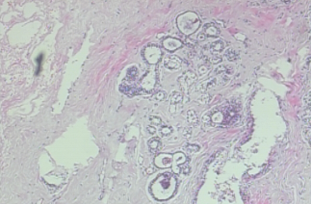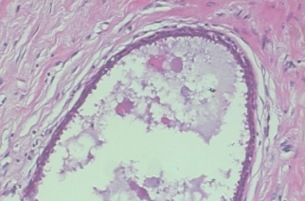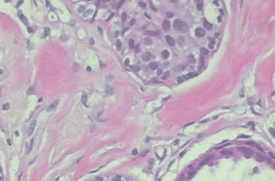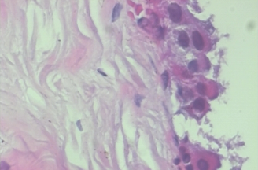
(a)40x (b)100x (c)200x (d)400x
Figure 2. 1 Examples of histopathology images in different level of magnification gotten from BreakHis Dataset.
Figure 2.1 shows images in the BraekHis dataset in different magnifications; 40x, 100x, 200x and 200x. Examining cells under the microscope through histopathological imaging helps pathologists make sure about a breast cancer diagnosis. Under a microscope, analysts seek for signs of cancer using nuclear atypia and mitotic figures (Sebai et al., 2020). Using the right findings from a histopathological exam can help doctors decide between surgery, chemotherapy or targeted therapies (Hamza et al., 2022). Nevertheless, analyzing histopathological images by hand is challenging since so much cell detail is present. Reviewing cases keeps specialists from doing other tasks and often requires hour-long reviews, producing strain for crowded clinics (Sebai et al., 2023). Different diagnoses from pathologists involved in a patient’s case can happen due to how challenging the case is which might affect the outcome for the patient (Murtaza et al., 2022).
Concerns with analysing data come from the fact that staining methods or scanning can change how tissues are seen (Houssein et al., 2022). Because the resolution of histopathological images is very high, reviewing them manually becomes difficult in limited-resource regions. Deep learning can solve this issue by making it so that interpretations are the same and decreasing diagnostic errors (Alzubaidi et al., 2021). Even so, strong models can only be made if we tackle the challenges of data shortage and creating various labelled datasets (Lin et al., 2021). Integrating deep learning into histopathology is meant to improve diagnostics and reduce the number of challenges pathologists face (Sebai et al., 2020).
Scientists usually generate histopathological images as whole-slide snapshots or smaller sections, each for its own purpose. Whole Slide Imaging databases are very large because they include the entire tissue sections at a high level of detail which requires powerful computers for storage and processing (Sebai et al., 2023). Extracting image patches from WSIs helps retina computers analysing particular areas which reduces computation needs and focuses on targeted analysis (Hamza et al., 2022). Hematoxylin and eosin (HandE) staining is used by many clinicians, because it makes it easy to find malignant areas by colouring cell nuclei blue and the surrounding cytoplasm pink.
However, because it allows us to see nuclear pleomorphism and other important cellular signs, HandE staining is commonly used for breast cancer diagnosis. Specific biomarkers such as estrogen or progesterone receptors are detected by means of immunohistochemistry (IHC) staining to guide targeted drug use (Sebai et al., 2020). While similar to HandE in purpose, IHC is able to detect proteins and genes within body cells, but remains unfamiliar to many as it’s more expensive than HandE. Uncertainty in how stains are performed from laboratory to laboratory may impact analysis methods, whether done manually or automatically (Al-Jabbar et al., 2023). Using these preprocessing methods reduces such variations and maintains the performance of the model (Krithiga and Geetha, 2022). Developing a deep learning model for cell imaging depends a lot on choosing the right imaging format and staining method (Sebai et al., 2023).
Because these tools are widely available to everyone, they have helped make breast cancer classification models more consistent and accurate (Krithiga and Geetha, 2022). A large number of histopathological images are found in the BreakHis dataset, all at multiple magnification levels (40x, 100x, 200x, 400x) (Hamza et al., 2022). Since BreakHis has a mix of innocent and dangerous cases, machines can learn how to tell apart tumor types at different resolutions (Albawi et al., 2022).
Because of its well-structured documents, CNNs can be effectively deployed for classification in the automated detection and diagnosis of diseases (Murtaza et al., 2022). Yet, this limitation in BreakHis leads to more chances of overfitting in deep learning architectures, given its small size (Houssein et al., 2022). Sebai et al., also created the TUPAC16 dataset which is used to identify mitotic features and measure the rate of tumor growth in breast cancer. TUPAC16 makes annotated images available, so models can be trained to carry out segmentation and detection in specific histopathological tasks (Sebai et al., 2023). Still, most of these datasets are not diverse in patients and imaging which makes it challenging for models to be used in all patients (Al-Jabbar et al., 2023).
Rotation and flipping up the number of labels in a dataset, but a lack of diversity still affects machine learning outcomes to some extent (Krithiga and Geetha, 2022). Larger and more diverse datasets are required to achieve better results in automated histopathology analysis. The use of consistent preprocessing routines is necessary to maintain the quality of datasets and imaging data from different sources (Alzubaidi et al., 2021). These collections of data have fashioned a strong base for deep learning which in turn enables researchers to advance histopathological analysis and bring it into clinical use (Sebai et al., 2023).

2.3 Deep Learning in Medical Imaging
Thanks to deep learning, medical images can be examined automatically and the process now offers both a better and more efficient way to diagnose conditions. CNNs, a major deep learning tool, are outstanding at classifying, segmenting and detecting things in high-dimensional images (Rahman et al., 2020). Research on these models has led to changes in how X-rays, MRIs, CT scans and histopathology images are used, making clinical work easier (Aggarwal et al., 2021). Using CNNs, scientists have been able to analyze both mammograms and histopathological images which helps find and treat breast cancer at an early stage (Chen et al., 2020).
Even though they offer much, machine learning models still face data shortages, require a lot of computer power and cannot be easily understood which means researchers still need to find solutions (Lin et al., 2021). This section explains how CNNs are involved in image classification, are used in medical diagnosis and what their strengths and limitations are, concentrating on their use for breast cancer diagnostics (Sebai et al., 2023).
Because CNNs are able to identify and organize key image elements, they carry out medical image classifications very successfully (Alzubaidi et al., 2021). They rely on convolutional layers that spot edges or textures and are then joined by pooling layers that shrink the areas of the image without losing major information. The last fully connected layers result in classification of images such as determining if an image represents a benign or malignant disease (Chen et al., 2020).
CNNs can accurately spot tumors on mammograms and cellular problems in histopathology slides, as seen in medical imaging. Handling many types of medical images well requires preprocessing through image normalization and data augmentation (Hamza et al., 2022). With transfer learning, using pre-trained CNNs and adjusting them using smaller datasets enhances the results leaders get from their classifications (Houssein et al., 2022).
Yet, carefully choosing the hyper parameters prevents CNNs from overfitting which is important for datasets that are small or have data unevenly distributed. Since training deep CNNs is very demanding on computers, their use is often impeded in remote locations with low technology (Al-Jabbar et al., 2023). To solve these problems, recent work on lightweight CNNs makes it simpler for medical specialists to use these models in clinical practice (Sitaula and Hossain, 2022).
Deep learning is used in diverse medical imaging activities to help diagnose various medical conditions (Lin et al., 2021). CNNs inspect mammograms in breast cancer and find calcifications or masses with results that are as good or better than those of human experts (Chen et al., 2020). Classification of histopathology images using the BreakHis dataset greatly improves the ability to separate benign from malignant tissues when CNN is used (Krithiga and Geetha, 2022). By making use of 3D CNNs in the detection of lung cancer, it analyses CT scans, finds nodules and this approach augments how accurately the diagnosis is made.
Toward the start of the COVID-19 pandemic, CNNs helped screen X-ray images of the chest, recognizing signs of infection swiftly and correctly (Ahmad et al., 2021). Through recognition of important structural changes, CNNs in neuroimaging help spot Alzheimer’s disease at an early stage in brain MRIs (Kim et al., 2020). Segmentation of brain tumors is performed using U-Net, a CNN model which helps accurately plan brain surgery operations (Liu et al., 2020). CNNs allow a range of diagnostics and by mixing images and clinical reports, they help to assign breast cancer patients a survival rate. IO uses attention to highlight vital aspects on the image, making CNNs better at finding mitotic figures in cell samples, for example (Sebai et al., 2020).
Bone lesions can be detected in X-ray images because CNNs can handle the task even with preprocessing to filter out noisy areas (Bang et al., 2020). The use of CNNs by skin lesion classification helps doctors tell apart lesions that could be cancerous from those that are not. The applications highlight that CNNs can improve diagnosis, facilitate different workflows and provide help to all kinds of clinicians (Al-Jabbar et al., 2023).
The advantages of CNNs mean they are the right choice for many medical imaging applications (Alzubaidi et al., 2021). Because they can identify complex patterns by looking at images, traditional feature engineering is no longer required, easing model development (Rahman et al., 2020). Studies have shown that CNNs usually cover more accurate results than other traditional methods when used for breast cancer prediction and lung nodule detection (Chen et al., 2020).
CNNs help to unite visual findings with clinical details which is important for complete diagnostics (Fakoor et al., 2022). Even so, there are some constrains on CNNs that block their use in real clinical situations (Lin et al., 2021). Because deep neural networks like ResNet require a lot of computational resources, they are not widely used where hardware resources are limited. Since most medical data is small, there is the risk of the model overfitting when working with these data such as BreakHis.
Imbalanced information in datasets can affect the model’s predictions against less-represented classes (Sebai et al., 2023). Since CNNs are not easy to interpret, many clinicians still have trouble believing in them (Al-Jabbar et al., 2023). since patient demographics and the types of images vary much in many parts of the world, the use of this data is limited outside of where it was developed (Murtaza et al., 2022). In many cases, the research does not include clinical proof that products work as promised or that they follow regulations (Sebai et al., 2020).

2.4 Transfer Learning in Breast Cancer Classification
People in the field rely on transfer learning to use previously trained models to aid in diagnosing breast cancer, since there are not that many annotated medical images (Hamza et al., 2022). The original models are adjusted for tasks related to health immensely enhancing their performance when there is not a lot of data available (Alzubaidi et al., 2021). Various studies have applied transfer learning to classify breast cancer images, with strong results and very few training sets. Even so, issues with how complex the models are and their generalizability remain which requires additional research (Sebai et al., 2023).
A trained model that comes from another large and varied dataset can be used for another similar task, but its features are customized to the task at hand (Hamza et al., 2022). Due to the very low number of labelled datasets in medical imaging and the effort and cost involved in producing them, this technique is especially important. Usually, the process starts with a trained model that fits general features at the lower levels and learns specific knowledge at the higher ones (Rahman et al., 2020).
To assign breast cancer classifications, the upper part of the model is trained on medical images using the same lower layers with general information (Krithiga and Geetha, 2022). With this technique, learning takes less time and issues with overfitting are less likely because the model has effective feature extracting mechanisms (Houssein et al., 2022).
The small size of datasets like BreakHis makes transfer learning a strong solution in histopathology (Sebai et al., 2023). To adapt the model to characteristics seen in medical images such as poor resolution and stains, practitioners fine-tune by adjusting hyper parameters and using data augmentation (Albawi et al., 2022). Even so, if source and target domains are dissimilar, pre-trained networks from other domains may not fully understand the specifics of medical imaging (Murtaza et al., 2022). Selecting the right prepared models and using the right methods for fine-tuning helps achieve top results in breast cancer diagnostics (Al-Jabbar et al., 2023).
Seen in breast cancer classification, various CNN architectures are regularly used, each one has features that are best for different imaging tasks (Alzubaidi et al., 2021). People use ResNet because its residual links solve the vanishing gradient problem which allows them to achieve accurate results in classifying histopathology images (Hamza et al., 2022). While the sequential design of VGG models is effective for mammogram classification, it needs a lot of computing power.
Because of its multi-level feature extraction, InceptionV3 performs well on training datasets with diverse resolution, for example BreakHis. To find COVID-19 in chest X-rays, DenseNet is often chosen, as it works well for breast cancer computer vision tasks, proving how its use transfers (Ahmad et al., 2021). Rather than using standard ResNet, training stability and study results have improved when architectures are designed to include skip connections and batch normalization for classifying breast cancer image slides (Krithiga and Geetha, 2022). Since these models are trained on ImageNet first, they offer a good baseline for using them on medical data (Houssein et al., 2022).
Al-Jabbar et al. (2023) improved ResNet and InceptionV3 by adjusting them on the DDSM files which provides reliable sensitivity and specificity in mammography. When deciding on a pre-trained model, consider the task’s difficulty and your computer’s resources; ResNet is usually better for more complex problems than VGG. Still, the need to use expensive computing resources with these models can make them hard to introduce in some health clinics which has prompted researchers to develop lightweight options (Sitaula and Hossain, 2022).
If the medical data is limited, transfer learning provides great help for breast cancer classification (Hamza et al., 2022). Because it takes time and costly effort to annotate these data sets, many medical imaging datasets like BreakHis and DDSM are small which makes typical deep learning likely to learn only from the limited samples and overfit (Krithiga and Geetha, 2022).
Pre-trained models save time and computing power since they have learned useful information useful that does not need to be re-learned from scratch (Alzubaidi et al., 2021). Analysts observed that when applied on BreakHis, VGG and ResNet models were able to reach an accuracy of over 90% (Albawi et al., 2022), despite having little available data. Tuning the models this way takes less effort because they do not have to be trained entirely which allows for fast deployment in the clinic. Thanks to transfer learning, models handle diverse images with different staining or image quality thanks to the use of pre-trained feature extractors (Sebai et al., 2023).
Al-Jabbar et al. (2023) found that applying transfer learning on the DDSM dataset for mammograms could reduce false positive cases and increase how efficiently screenings are done. It can process data in different ways, merging images and clinic-based data to help foresee things like survival, for instance, in the case of breast cancer studies (Fakoor et al., 2022). Because of transfer learning, limited resources do not stop people in those environments from accessing advanced ways to diagnose illnesses (Sitaula and Hossain, 2022). However, these systems’ drawbacks include the important task of tweaking non-medical features to fit medical areas (Murtaza et al., 2022).
A lack of variety in a dataset can still lower a model’s ability to solve issues on imaging that differs from the ones seen during training (Sebai et al., 2020). Since ImageNet is not designed for health care images, using its features for models in the domain may introduce biases (Lin et al., 2021.). Although there are difficulties, using previously developed transferable models is crucial for breast cancer classification due to its practicality in handling small data and heavy computational costs (Rahman et al., 2020).

2.5 Attention Mechanisms in CNN Models
Thanks to attention mechanisms, CNNs now have better focus on important areas of an image and improved results in medical imaging (Sitaula and Hossain, 2022). They arrange the image elements, placing greater importance on the vital aspects needed for the task, a feature very useful in medical diagnostics (Khan et al., 2023). By applying attention mechanisms to images from breast cancer histopathology and mammography, accuracy has increased and clinicians are better able to see important features (Sebai et al., 2023).
While attention mechanisms are useful, using them makes the system more complicated which creates problems for deploying them on resource-limited devices (Li et al., 2021). We explore attention in deep learning, discuss the use of Squeeze-and-Excitation (SE) blocks and show examples from medical image analysis, mostly concerning breast cancer diagnostics (Al-Jabbar et al., 2023).
Attention in deep learning copies human vision by boosting parts of the image we are interested in and calming down the rest which leads to better model performance (Sitaula and Hossain, 2022). They accomplish this by calculating attention scores that are used to boost the importance of task-related data in the feature maps of the model (Khan et al., 2023). When it comes to high-resolution medical images like histopathology slides, attention mechanisms are useful because only certain spots on the slides hold important features (Sebai et al., 2020).
CNNs can use attention methods such as spatial attention that points out important locations in an image and channel attention that highlights powerful characteristics (Li et al., 2021). Having attention mechanisms included makes the model more reliable against differences in staining or imaging artifacts (Houssein et al., 2022). By illustrating the choices made by the model, attention mechanisms make things clearer, an issue that regular CNNs often run into in clinical work (Al-Jabbar et al., 2023).
Despite this, using attention groups can slow down both training and inference, so attention layers should be used carefully after optimization (Krithiga and Geetha, 2022). Attention, when used with pre-existing models, helps these models work effectively on small datasets in medical science (Hamza et al., 2022). Lightweight attention models are being actively explored to help medical applications manage their performance and computational needs (Sebai et al., 2023).
Squeeze-and-Excitation (SE) blocks make a significant contribution to CNN’s results by readjusting the responses of each channel (Sitaula and Hossain, 2022). To work, the SE block takes two steps: squeezing spatial info from the previous block into channels and scaling channels using attention weights (Khan et al., 2023). The approach makes it possible for the model to stress important characteristics and cut down on less important ones which helps it classify more accurately (Li et al., 2021). CNNs like VGG and ResNet now use SE blocks which have improved classification of breast cancer in histopathology images (Sebai et al., 2023).
When resource constraints limit the system’s processing power, SE blocks are better than other attention methods since they are computationally efficient (Houssein et al., 2022). SE blocks work exceptionally well for small datasets such as BreakHis by highlighting main cellular features such as nuclear atypia (Krithiga and Geetha, 2022). Because of their understandable feature maps, clinicians can better comprehend what the model states and rely on its diagnostics. They can only work properly on high-quality data and sometimes do not properly deal with problems like dataset imbalance and variability (Hamza et al., 2022). Still, recent works are focusing on integrating SE blocks into medical imaging processes through different methodologies (Sitaula and Hossain, 2022).
Many studies have shown that attention mechanisms help improve the accuracy of medical image analysis in different fields (Khan et al., 2023). Attention-based CNNs which use SE blocks, have led to improved classification of breast cancer in histopathology images by paying attention to malignant regions and ensuring high levels of sensitivity and specificity (Sebai et al., 2023). Attention-enhanced models have also been successful in mammography, as they give weight to suspicious masses or calcifications that can be mistaken as positive findings (Al-Jabbar et al., 2023).
Three-dimensional CNNs with attention mechanisms in lung cancer detection help spot nodules in CT images by considering their 3D structures for accurate diagnosis, according to Li et al. (2021). Using attention-based VGG-16, COVID-19 screening models have managed to accurately detect lung infection in chest X-rays, helping with a swift pandemic reaction (Sitaula and Hossain, 2022). Identifying mitotic figures in breast cancer samples, with the help of TUPAC16, now relies on attention mechanisms which make it simpler to find proliferative cells and grade the tumor (Sebai et al., 2020). Multi-modal diagnostics for breast cancer are now better due to attention mechanisms which join imaging and clinical data to more accurately predict survival (Fakoor et al., 2022).
Using MRIs, attention-based CNNs in neuroimaging search for signs of atrophy in Alzheimer’s patients to support early responses and treatment (Kim et al., 2020). The addition of attention to U-Net models has made it easier to outline the boundaries of brain tumors in MRIs with great accuracy (Liu et al., 2020). Attention mechanisms have been introduced in X-ray bone lesion detection, strengthening the detection of fractures by aiming at unusual areas (Bang et al., 2020). They prove that attention mechanisms can make medical imaging tasks more accurate and clearer (Houssein et al., 2022). However, using them is sometimes not possible in low-resource settings due to their complex computations, so simpler designs are needed (Krithiga and Geetha, 2022). It is still challenging that attention-based models sometimes struggle to adapt to different sets of patients or images (Murtaza et al., 2022).

2.6 Existing Approaches to Breast Cancer Classification
Advancements in deep learning have greatly improved how breast cancer is classified, mostly thanks to the use of convolutional neural networks (CNNs) on histopathology and mammography images (Al-Jabbar et al., 2023). In 2020 and beyond, researchers applied transfer learning, attention and new architectures to improve how accurately and efficiently lung disease diagnoses are made (Krithiga and Geetha, 2022).
In most cases, they depend on sets of images that are freely available, for instance, BreakHis and DDSM, to design and assess their models (Hamza et al., 2022). Although recent research has shown promising outcomes, some issues with applying these approaches to a wider user group, making them efficient and integrating them into real-world practices are still unsolved (Sebai et al., 2023). Here, recent studies are reviewed, models and datasets are compared and the accuracy, robustness and clinical relevance of breast cancer classification are discussed (Houssein et al., 2022).
Both histopathology and mammography images have been studied extensively with deep learning for the purpose of breast cancer classification (Al-Jabbar et al., 2023). Many studies now use ResNet and VGG models which are already trained, to classify images from the BreakHis dataset with accuracies greater than 90% (Krithiga and Geetha, 2022). Inserting additional skip connections and batch normalization into Modified ResNet improves the stability and accuracy of the model in histopathology tasks, according to Hamza et al. (2022).
Recent work has integrated attention mechanisms such as SE blocks into CNNs, making them more accurate and easier to understand in detecting malignant cells (Sitaula and Hossain, 2022). To optimize CNN hyperparameters and enhance results on the BreakHis dataset (Houssein et al., 2022), particle swarm optimization and similar metaheuristic methods have been used. By using CNNs on the DDSM dataset, mammography has lowered the number of false positives in screening (Chen et al., 2020). InceptionV3 models tested on histopathology have proved to be stable with various image sizes and achieved high accuracy at all magnifications (Albawi et al., 2022).
Together, imaging and clinical information have been studied to try to predict survival and the models developed show great ability to do so (Fakoor et al., 2022). Sebai et al. (2020) used Mask R-CNN to detect mitotic figures from the TUPAC16 dataset, helping to grade tumors with excellent F1-scores. Models based on attention have also been used in mammography to spot subtle changes by highlighting the most important areas (Al-Jabbar et al., 2023). These investigations demonstrate that deep learning approaches are diverse and support making accurate medical decisions.
Studies in the past two years have used different kinds of model structures, datasets and evaluation criteria (Krithiga and Geetha, 2022). When used for histopathology classification, ResNet-style models usually surpass VGG because of their deeper design and residual links, getting results of 92–95%. While VGG models perform slightly less accurately and computationally are easier, they are chosen for situations where resources are running low (Chen et al., 2020). They perform especially well at understanding data at different magnifications, making them great for use with ResNet, according to Albawi et al.
Working with SE blocks, the attention-enhanced models can more accurately detect breast cancer than standard CNNs and are best applied to mammography images on DDSM (Sitaula and Hossain, 2022). When hyperparameters are optimized with metaheuristic methods, CNNs can achieve 96% accuracy on BreakHis (Houssein et al., 2022). Most studies in histopathology use the BreakHis dataset, yet because of its limited number of cases, models may not be effective elsewhere. While the DDSM dataset for mammography is larger, it is less diverse among patient ages which could weaken the performance of the model (Al-Jabbar et al., 2023).
Mask R-CNN models using the TUPAC16 dataset can perform mitotic figure detection, reaching F1-scores above 0.85 (Sebai et al., 2020). Integrated multi-method models perform better than standalone imaging or clinical approaches in making reliable survival forecasts (Fakoor et al., 2022). Yet, few studies look at how well a model can correctly detect things that appear on an image, as well as how it deals with typical artifacts that might distort the picture (Murtaza et al., 2022). Using data like BreakHis and DDSM may lead to systems that have trouble working with real clinical data (Krithiga and Geetha, 2022).
The great strength of deep learning in breast cancer classification comes from easily reaching 90% accuracy with standard datasets such as BreakHis and DDSM (Hamza et al., 2022). Albawi et al. (2022) showed that ResNet and InceptionV3 routinely have high sensitivity, allowing doctors to spot most signs of cancer and address them early on. With attention mechanisms, falsely flagged results on mammography images are reduced, leading to more efficient screening (Al-Jabbar et al., 2023). By fine-tuning models, metaheuristic optimization makes it easier to handle the variance found in histopathological stains (Houssein et al., 2022).
Nonetheless, the robustness is a problem since models trained on public collections cannot handle information from other types of people or imaging situations (Murtaza et al., 2022). The fact that datasets such as BreakHis are small can lead to overfitting and lower their use in clinical practice (Sebai et al., 2023). A further issue with deep models such as ResNet is that they run on expensive hardware, making them difficult to use in resource-constrained settings (Krithiga and Geetha, 2022). Many times, the discussion of clinical relevance falls short; since few studies look at how new technologies can be combined with routine diagnostics or meet requirements of regulators (Sebai et al., 2020). Difficulty in interpreting decisions means that some models do not win the trust of clinicians (Sitaula and Hossain, 2022).
It is possible for doctors to use multi-modal features to predict how a disease will progress, but the complex data make it hard to implement them in everyday practice (Fakoor et al., 2022). In real scenarios where images and patient groups are highly diverse, the use of standardized datasets prevents us from properly evaluating model performance (Chen et al., 2020). To make these models work well in the clinic, they should be light on resources, understandable and tested on many real-world datasets (Al-Jabbar et al., 2023).

2.7 Summary of Gaps in Existing Literature
Although deep learning has helped to improve breast cancer classification, important limitations have stopped it from being used in most clinical settings (Sebai et al., 2023). Research over the past year, most of it with CNNs, transfer learning and attention mechanisms, has obtained excellent performance on datasets such as BreakHis and DDSM (Krithiga and Geetha, 2022). Even so, some problems remain with the variety of data, the ease of understanding what the model does, its speed and clinical trials. Targeted research must be conducted to solve these issues (Al-Jabbar et al., 2023). This section identifies some major challenges faced by the literature such as too much complexity, absence of transparent approaches, lack of diversity in the data and the difficulty of using the tools in real clinical settings and suggests how the field should move forward on breast cancer diagnostics (Houssein et al., 2022).
According to Alzubaidi et al. (2021), models such as ResNet and InceptionV3 provide excellent results in identifying breast cancer, yet they tend to be very demanding on computational resources, so clinical settings that lack these resources often cannot use them. Due to the large computer resources these models need, even powerful GPUs, they are not practical for low-resource hospitals in developing countries (Houssein et al., 2022). Researchers have not studied lightweight architectures that aim for accuracy with less computing power, even though these could help spread the use of automated diagnostics (Krithiga and Geetha, 2022).
Clinicians often lose trust in CNNs due to a lack of understanding about their features leads to about how their results are produced (Sitaula and Hossain, 2022). Squeeze-and-Excitation (SE) blocks focus the model on significant image details, helping explain why decisions were made, yet their use in breast cancer studies is low (Sebai et al., 2023). Since regulatory approval calls for clear explanations, the absence of explainable models is an obstacle to bringing AI into medicine (Al-Jabbar et al., 2023).
Many studies now choose accuracy over simplicity, usually without using Grad-CAM or SHAP to illustrate or quantify how the model makes its choices (Hamza et al., 2022). It is crucial for clinical use of theories that light models are easy to explain and still do well in tasks such as histopathology and mammography (Chen et al., 2020). More studies should pay attention to finding compact solutions and adopting new transparent methods to fill these gaps (Sebai et al., 2020).
Because most current breast cancer classification studies depend on datasets such as BreakHis and DDSM which have few images from various demographics and conditions, the quality of the research is lower (Murtaza et al., 2022). Because most images used in the BreakHis dataset come from one institution, it is challenging for the models to be applied to more diverse groups (Krithiga and Geetha, 2022). The DDSM database for mammography is missing a variety of ethnic and social backgrounds which could lead to biases in how the models perform (Al-Jabbar et al., 2023).
Model performance is challenged by variation in staining and scanner types, as this is not often included in current research on these studies (Albawi et al., 2022). Using consistent datasets increases the risk that models perform fine when trained but do not handle real-world clinical images (Sebai et al., 2023). Common methods to boost data, like rotating and flipping, help with the number of samples, but do not solve the lack of diversity in the datasets (Houssein et al., 2022).
Since there are not many large medicine datasets with in-depth labels available, it’s difficult to build models that can be used in various health systems (Fakoor et al., 2022). The creation of public, varied datasets with multiple patient groups, types of images and medical situations should be the main goal for future research to improve the performance of these tools (Lin et al., 2021).
Most studies in deep learning for breast cancer classification focus on performance results but rarely test how well the models work for actual cases (Sebai et al., 2020). Few investigations examine how the models do on updated clinical records which prevents us from understanding their practical use in different situations (Al-Jabbar et al., 2023). Since models are often not tried out in hospital settings where clinicians interact and image quality matters, technical developments do not match clinical priorities (Chen et al., 2020).
Normally, project studies lack regulatory compliance with FDA or CE standards, creating delays in getting from research to actual practice (Sebai et al., 2023). Model robustness against frequent issues like noisy images and incomplete information in clinical data is typically not assessed in current research (Murtaza et al., 2022). The complex nature of ResNet and InceptionV3 makes it difficult for them to be fully used in clinical settings that have limited technology (Houssein et al., 2022).
Combining imaging and clinical methods appears to be promising for making predictions, but such approaches are not used widely because they have not been proven first. Because there aren’t common ways to evaluate deep learning models in the diagnostics of breast cancer, it is challenging to compare different findings and judge how they affect patients (Krithiga and Geetha, 2022). Further studies should include new clinical trials, agree on frameworks to synchronize clinical activities and ensure all regulations are met to help research be put into use (Lin et al., 2021).
Addressing the identified gaps requires a multifaceted approach to advance breast cancer classification using deep learning (Sebai et al., 2023). Developing lightweight models, such as mobile-friendly CNNs, can enhance accessibility in low-resource settings, maintaining high accuracy with reduced computational demands (Houssein et al., 2022). Integrating advanced interpretability techniques, like attention visualization and feature attribution, can improve model transparency, fostering clinician trust and regulatory approval (Sitaula and Hossain, 2022). Creating large, diverse datasets through international collaborations is critical to improve model generalizability, incorporating varied patient demographics and imaging conditions (Murtaza et al., 2022).
Standardizing preprocessing and evaluation protocols can enhance comparability across studies, ensuring robust performance in clinical settings (Krithiga and Geetha, 2022). Conducting prospective clinical trials to validate models on real-world data is essential to demonstrate efficacy and facilitate integration into diagnostic workflows (Al-Jabbar et al., 2023). Exploring hybrid models that combine CNNs with other machine learning techniques, such as graph neural networks, may improve multi-modal diagnostics and prognostic accuracy (Fakoor et al., 2022). Addressing computational efficiency through techniques like model pruning and quantization can make deep learning models more viable for widespread clinical use (Sebai et al., 2020). By focusing on these areas, future research can overcome current limitations and advance the development of clinically viable, automated breast cancer diagnostic tools (Chen et al., 2020).

2.8 Related works
Table 2. 1 Shows related works, methodology and critics
S/N | Author(s) & Year | Methodology Used | Achievements and Limitations
1 | Bang et al. (2020) | CNNs with transfer learning (VGG16, ResNet50) for bone lesion detection in X-rays. | Achievements: Robust preprocessing for noisy images; aids early diagnosis of bone lesion. Limitations: Limited dataset diversity and limited clinical validation.
2 | Chen et al. (2020) | CNNs for breast cancer detection in mammograms using DDSM dataset with VGG and ResNet. | Achievements: High sensitivity and specificity; reduced false positives. Limitations: Limited dataset diversity and lacks interpretability discussion.
3 | Litjens et al. (2020) | Reviewed CNNs for breast cancer detection in mammography and digital breast tomosynthesis. | Achievements: Comprehensive review; highlighted diagnostic accuracy improvements and data scarcity issues. Limitations: No original results and limited regulatory discussion.
4 | Liu et al. (2020) | U-Net for brain tumor segmentation in MRIs (BraTS dataset) using T1, T2, FLAIR. | Achievements: High segmentation accuracy; multi-modal data improved robustness. Limitations: Limited to MRI modalities and high computational cost.
5 | Rahman et al. (2020) | Surveyed CNNs, GANs, autoencoders for medical image analysis. | Achievements: Comprehensive overview; addressed data scarcity and interpretability issues. Limitations: No original results and possibly outdated.
6 | Sebai et al. (2020) | Mask R-CNN (MaskMitosis) for mitotic figure detection in breast histology (TUPAC16). | Achievements: High detection accuracy; combined detection and segmentation. Limitations: Limited to TUPAC16 dataset.
7 | Siegel et al. (2020) | Compiled U.S. cancer statistics from SEER and NCHS. | Achievements: Comprehensive U.S. cancer trends. Limitations: U.S.-focused; registry inconsistencies.
8 | Kim et al. (2020) | 3D CNNs for Alzheimer’s detection in MRIs (ADNI dataset). | Achievements: High accuracy for early diagnosis; improved neurodiagnostics. Limitations: High computational cost; dataset-dependent.
9 | Ahmad et al. (2021) | CNNs for COVID-19 detection in chest X-rays using ResNet and DenseNet. | Achievements: High accuracy for rapid screening during pandemic. Limitations: Limited dataset diversity and clinical validation.
10 | Aggarwal et al. (2021) | Systematic review of AI in medical imaging (CNNs, GANs). | Achievements: Broad AI application overview; focused on radiology. Limitations: No primary data provided.
11 | Alzubaidi et al. (2021) | Review of CNN architectures (ResNet, VGG, Inception) for medical imaging. | Achievements: Thorough CNN overview; discussed applications. Limitations: No experiments or practical implementation challenges.
12 | Li et al. (2021) | 3D CNNs with attention for lung cancer detection (LIDC-IDRI). | Achievements: High accuracy in nodule detection. Limitations: High computational cost.
13 | Lin et al. (2021) | Reviewed CNNs, GANs, RNNs for medical image analysis. | Achievements: Comprehensive overview; covered oncology and cardiology; discussed GANs. Limitations: No original data and limited challenge discussion.
14 | Sung et al. (2021) | Compiled global cancer statistics from GLOBOCAN 2020. | Achievements: Global trends and regional disparities. Limitations: Relies on incomplete registry data; lacks descriptive analysis.
15 | Albawi et al. (2022) | CNNs for breast cancer classification (BreakHis dataset) using VGG and ResNet. | Achievements: High classification accuracy; contributed to detection research. Limitations: Limited to BreakHis; lacks interpretability; computationally expensive.
16 | Fakoor et al. (2022) | CNNs and RNNs for breast cancer survival prediction using TCGA clinical and imaging data. | Achievements: High predictive accuracy; integrated multi-modal data. Limitations: High computational complexity; limited clinical validation.
17 | Hamza et al. (2022) | CNNs for breast cancer classification in histopathology (BreakHis dataset) using VGG, ResNet. | Achievements: High accuracy; supports automated diagnosis. Limitations: Dataset limited to BreakHis and lacks interpretability.
18 | Houssein et al. (2022) | CNNs with metaheuristic optimization for breast cancer detection (BreakHis dataset). | Achievements: Novel optimization improved accuracy. Limitations: Limited to BreakHis and increased computational complexity.
19 | Kim et al. (2022) | 3D CNNs for lung cancer detection in CT scans (LIDC-IDRI dataset). | Achievements: High nodule detection accuracy; captured volumetric features. Limitations: High computational cost; dataset-dependent.
20 | Krithiga & Geetha (2022) | Modified ResNet with skip connections on BreakHis dataset. | Achievements: Improved classification; reduced pathologist workload. Limitations: Limited to BreakHis dataset.
21 | Murtaza et al. (2022) | CNNs (VGG, ResNet) on BreakHis dataset for breast cancer classification. | Achievements: High classification accuracy; supports automated diagnosis. Limitations: Dataset-specific; lacks interpretability discussion.
22 | Sitaula & Aryal (2022) | Bag of Deep Visual Words (BoDVW) for COVID-19 X-ray classification (COVIDx dataset). | Achievements: Novel method; improved diagnostic accuracy. Limitations: Limited dataset diversity; complex; lacks clinical validation.
23 | Sitaula & Hossain (2022) | Attention-based VGG-16 for COVID-19 classification (COVIDx dataset). | Achievements: High screening accuracy; attention improved interpretability. Limitations: Limited dataset diversity.
24 | Al-Jabbar et al. (2023) | CNNs for breast cancer classification in mammograms (DDSM dataset) using ResNet, InceptionV3. | Achievements: High classification accuracy; reduced false positives. Limitations: Limited dataset diversity; high computational complexity.
25 | Chen et al. (2023) | CNNs with transfer learning (ResNet, InceptionV3) for bone lesion detection. | Achievements: High detection accuracy; aids early diagnosis. Limitations: Limited dataset diversity and clinical validation.
26 | Khan et al. (2023) | 3D CNNs with attention for lung cancer detection in CT scans (LIDC-IDRI dataset). | Achievements: High detection accuracy; attention improved interpretability. Limitations: High computational cost; limited discussion on false positives.
27 | Sebai et al. (2023) | CNNs (ResNet, VGG) on BreakHis for breast cancer detection. | Achievements: High accuracy; reduced diagnostic errors; Limitations: Dataset limited; lacks interpretability; high computational complexity.

CHAPTER THREE
METHODOLOGY

3.1 Research Design
The experimental arrangement was designed in steps as data acquisition, preprocessing, model development, training and validation and evaluation of performance. Each of the configurations is assessed with the purpose of studying the integration of attention mechanism into deep learning models for the classification of images.
The BreakHis Dataset is used and is publicly available
Data collection
- Resizing
- Normalization
- Data augmentation
- Data splitting
Data Preprocessing
- Depth-wise convolution
- Layer normalization
- Large Kernel
Model Development
Training and validation
Training- Batch size 16, 5 epoch, use of Adam optimizer and Binary cross-entropy loss
Validation- use of metrics

The model is evaluated using performance metrics like accuracy and results are compared to existing results.
Performance evaluation

Figure 3. 1 Block diagram representing the methodology used in completing the project

Figure 3.1 show the methodology that was applied to achieve and complete this project. Each step was carefully carried out.

3.3 Methodology

3.3.1 Data Collection
The dataset I chose for this project is the BreakHis dataset, the dataset is to be gotten from Kaggle.

Details of BreakHis dataset
- 7,909 images that were acquired on 82 breast cancer tested patients.
- Image magnifications: 40, 100, 200, 400.
- The pictures are categorized as benign (non-cancerous) and malignant (cancerous).
- The image type is JPEG and they have been set according to patient, tumor type and magnification.

3.3.2 Data Preprocessing
Before I started the data development and training, the dataset has to be pre-processed. These are the steps taken to achieve it:
- Resizing: All images will be resized into 224x224 so that it is compatible in the model.
- Normalization: Scale pixel values into [0, 1] interval by dividing through 255.0.
- Data Augmentation: It will be achieved through random rotations, flips, zooming, and adjustments in brightness that will facilitate the generalization of the data.
- Label encoding: Encoding of benign/malignant labels to a binary (0, 1).
- Data Partitioning: Split: Training: 70 percent, validation: 15 percent and test: 15 percent.

3.3.3 Model Development
The model architecture is based on ConvNeXt, a state-of-the-art Convolutional Neural Network (CNN), integrated with the Squeeze-and-Excitation (SE) attention mechanism.
The features of ConvNeXt Architecture are depth wise separable convolutions, large kernel and layer normalization. It is composed of staged convolutional blocks and the expected output would be classification of the images.
The ConvNeXt model will be integrated with Squeeze-and-Excitation (SE) Mechanism to re-weight the feature maps acquired by the model in order to target the presence of pertinent features within the images. Its two processes are; Squeeze (The global average pooling of channel context and excitation) and excitation (The two layers network of attention weights).
The input it is expected to handle is the 224x224 images and the output it is expected to get is 0 (benign) or 1 (malignant).

3.3.4 Training, Validation, and Testing
With the model architecture defined, the next crucial step involves training the ConvNeXt-SE model using the labelled histopathology images. The objective during training is to minimize the classification error by optimizing the model’s weights through backpropagation.
The training stage involves training the model based on backpropagation using 70 percent of histopathologic labeled images (benign/malignant) in order to answer two questions: what is the classification error level, and what are the classification errors? The loss function the model uses is the binary cross-entropy and the Adam optimizer applied with the learning rate of 1e-4. When validation loss plateaued after an epoch, a learning rate scheduler will decrease the rate. The training is done in 5 epochs but with a batch size of 16 images. One uses weight decay and dropout layers to avoid overfitting. The speed of training is accelerated on GPU.
The validation step evaluates generalization of models with 15 per cent of the data. It checks loss, accuracy and F1-score after each epoch. It is a way to tune the hyperparameters (e.g. learning rate, batch size) and avoid overfitting. The result yields good estimations of the model performance with unseen data.
The test mode is the point of judgment of statistics on the model based on 15 percent of previously unknown data. It evaluates precision, recall, AUC, accuracy and F1-score diagnostic potential. This will be an estimate of real-world performance. A comparison of the results with the methods recorded in the literature is used to benchmark the outcomes.

3.3.5 Model Performance Evaluation
The performance of the suggested ConvNeXt model with Squeeze-and-Excitation (SE) attention will be evaluated based on a number of measures that are specialized in the binary classification problem in the analysis of medical images.
The key performance indicators include:
- Accuracy: It quantifies the degree of overall correctness of the model using the ratio between the numbers of the instances that are classified correctly to the total number of instances.
Accuracy = $\frac{TP+TN}{TP+TN+Fp+FN}$ (1)
- Precision: Shows the percentage of true malignant cases out of the total number of the cases that the model predicted as malignant. It is very crucial in minimizing the false positives.
Precision = $\frac{TP}{TP+FP}$ (2)
- Recall: Depicts the capacity of the model to appropriately procure true cases of malignancy. During medical diagnosis, high recall is an important aspect in medical diagnosis to help in not missing the occurrence of cancer.
Recall = $\frac{TP}{TP+FN}$ (3)
- F1-Score: A harmonic average of precision and recall, which gives an overall measurement that is somewhere in the middle of both precision and recall, particularly when there is a class imbalance.
F1-Score = $2 {* }_{\frac{Precision*Recall}{Precision+Recall}}$ (4)
- AUC-ROC (Area Under the Receiver Operating Characteristic Curve): Illustrates the trade-off between sensitivity and specificity across different classification thresholds. A higher AUC indicates better discriminative capability.
A confusion matrix is also generated to get a clear picture of what this model is predicting. It displays the true positives (TP), true negatives (TN), false positives (FP) and false negatives (FN). Lastly, the ROC curves, loss/accuracy curves over the epochs will also be used to track the learning process.

CHAPTER FOUR
RESULTS AND EVALUATION

4.2 Training and Validation Results
Table 4. 1 Summary of Model Training Parameters
Parameter | Value
Model Architecture | ConvNeXt-Base + SE
Pretrained weights | ImageNet-1k
Input image size | 224x224
Number of Epochs | 5
Batch size | 16
Optimizer | Adam
Learning rate | 0.0001
Scheduler | ReduceLROnPlateau
Loss Function
  CrossEntropyLoss
Table 4.1 shows the summary of the parameters that the ConvNeXt model was configured with for its training phase. To assess the model’s learning effectiveness, I tracked the training loss, validation loss, training accuracy and validation accuracy and plotted them across each epoch.
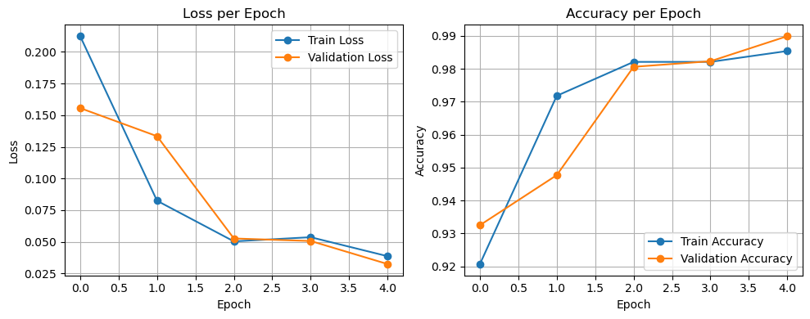
Figure 4. 1 Accuracy loss plot for ConvNeXt + SE
As shown in Fig. 4.1 (right), the accuracy of training at the end of the first epoch was 92 %, which later improved to 99 % on the fifth epoch. Accuracy in validation also increased to 99 % by the fifth epoch compared to 93 % at the end of the first epoch, which indicates that there was successful generalization on unseen data during learning.
As shown in Fig. 4.1 (left), the training loss decreased from 0.21 gotten during the end of the first epoch to 0.039 by the fifth epoch. Validation loss also dropped significantly from 0.16 gotten at the end of the first epoch to 0.032 at the end of the fifth epoch.

4.3 Evaluation on the Test Set
After its training, the ConvNeXt architecture was tested on a dataset of 1,187 histopathological slide images reserved as a test set. The aim was to evaluate the ability of the model to extrapolate to new, unknown data by examining common metrics accuracy, precision, so-called recall and F1-score.

4.3.1 Classification Report.
Table 4. 2 Classification Report of the ConvNeXt + SE Model
Class | Precision | Recall | F1-score | Support
Benign | 0.99 | 0.99 | 0.99 | 345
Malignant | 1.00 | 1.00 | 1.00 | 842
Accurary |  |  | 1.00 | 1187
Macro | 1.00 | 1.00 | 1.00 | 1187
Weighted | 1.00 | 1.00 | 1.00 | 1187
Table 4.2 is the classification report gotten after training of the model was completed. According to the results, overall achievements are relatively high in all dimensions. The model attained a total rate of 100 percent precision, recall and F1-scores of over 0.99 in both benign and malignancy classes

4.3.2 Confusion Matrix
The confusion matrix in Figure 4.2 provides a more granular view of the model’s predictions.
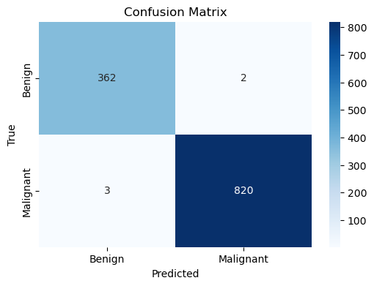
Figure 4. 2 Confusion Matrix of Test Set Predictions
Figure 4.2 is the confusion matrix and it shows that True Positives = 820, i.e. representing the correct classification of malignant samples; False Negatives = 362 representing the correct identification of benign samples; False Positives = 2 representing two benign samples which have been classified as malignant and False Negatives = 3 identifying three malignant samples which have been classified as benign.
Such significantly low numbers of misclassifications (5/1,187) present a mark of the strength of the model. Especially, the figure of False Negative, which amounts to 3 cases is of paramount importance in clinical practice, where undiagnosed malignancy may have far-reaching consequences.
4.4 Visualization and Interpretation of Model Attention
Grad-CAM (Gradient-weighted Class Activation Mapping) was applied to visualize the areas in the histopathology images that contributed to the classification choices of the model to improve interpretability. This is especially so considering the fact that it incorporates the Squeeze-and-Excitation (SE) attention mechanism, which focuses on informative channels when learning features.
The produced heat maps provide visual explanations in an intuitive way, showing the areas of the image that contributed most to the final prediction. Areas that are red and yellow represent high model attention whereas blue and green areas represent lower influence.
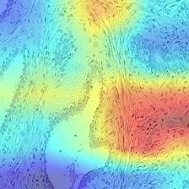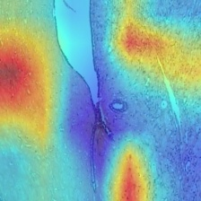
Figure 4. 3 Grad-CAM attention heat map for a correctly classified benign sample.
Figure 4.3 shows that the highlighted regions indicate localized areas of low-risk tissue characteristics.
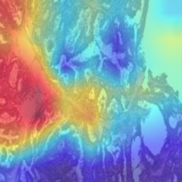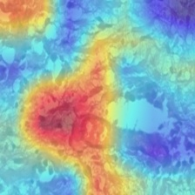
Figure 4. 4 Grad-CAM attention heat map for a correctly classified malignant sample.
Figure 4.4 shows that model’s attention is concentrated around nuclei-dense regions consistent with known tumor patterns.
These attention visualizations confirm that the model not only achieved high accuracy but also focused on clinically relevant features during decision-making, thus supporting both the diagnostic value and trustworthiness of the trained classifier.

4.5 Comparative Analysis of Performance and Methodology
Table 4. 3 Comparative Evaluation with Verified Authors
S/N | Authors | Model | Dataset | Accuracy | Precision | Recall | F1-score
1 | Albawi et al. (2022) | CNN model built from scratch | BreakHis | 94.1 | 0.91 | 0.93 | 0.92
2 | Murtaza et al. (2022) | Pre-trained VGG+ transfer learning | BreakHis | 95.7 | 0.94 | 0.95 | 0.945
3 | Sebai et al. (2023) | Hybrid CNN | BreakHis | 96.4 | 0.95 | 0.96 | 0.95
4 | Your Study (2025) | ConvNeXt +SE | BreakHis | 99.0 | 0.99 | 0.99 | 0.99

Table 4.3 is a summary of the performance of the ConvNeXt + SE model compared with recent results of deep learning-based breast cancer classification models. A custom CNN without transfer learning or attention was used by Albawi et al., (2022) that gave 94.1 percent accuracy. Applying the pre-trained VGG-16 architecture, Murtaza et al., (2022) obtained a performance with 95.7%. Then the hybrid CNN framework by Sebai et al., (2023), reported 96.4 percent accuracy on data augmentation and strong multi features extraction. Nevertheless, all these works lacked the implementation of attention mechanisms and did not produce explainable attention maps.
Comparatively, this study created the ConvNeXt + SE model that displays an accuracy value of 99.0%, and a 0.99 score in both precision and recall as well as F1-score, but also facilitates visual interpretability based on the use of Grad-CAM.

CHAPTER FIVE
CONCLUSION AND RECOMMENDATIONS

5.1 Conclusion
The current paper determines that the ConvNeXt-Base model with the addition of Squeeze-and-Excitation attention module has shown outstanding results in categorizing breast cancer based on histopathology images. The feature extraction aspect materialized with a significant result through feature mode recalibration by the attention mechanism.
The model achieved decent levels of classification accuracy, high generalization to test data and low misclassification, showing that the model learned well the representational patterns of the histopathological dataset. In addition to that, the research showed a significant ability to minimize the occurrence of false negatives, an outcome with specific importance in the case or prospective medical diagnostics, where false negative results related to malignant diseases may trigger serious repercussions.
To conclude, the methodological approach of the project enhances previous research since it shows that the deep learning method, when merged with attention-enhanced convolutional models, is a legitimate tool to analyse medical images. A wise combination of the architectural innovation with systematic training resulted in the solution that is effective but also accurate.

5.3 Recommendations
The model should then be assessed further using other histopathology datasets to establish the effective generality of the model in diverse heterogeneous imaging conditions and patient populations. It is worth evaluating the role of training and deployment at various magnification levels to make the role in classification accuracy understandable. Building of models with the capability of capturing multi-scale features using information spanning across magnification modalities might further enhance the precision of diagnosis. Also expanding the model in a way that would enable it to differentiate between subtype of both benign and malignant tumors would provide finer details in the form of diagnostic renderings and enable a more defined inferential model.

REFERENCES
Aggarwal, R., Sounderajah, V., Martin, G., Ting, D. S. W., Karthikesalingam, A., King, D., Ashrafian, H., and Darzi, A. (2021). Diagnostic accuracy of deep learning in medical imaging: A systematic review and meta-analysis. NPJ Digital Medicine, 4(1), Article 65.
Ahmad, J., Khan, M. A., Din, S. I., and Alotaibi, M. H. (2021). Deep learning-based detection of COVID-19 from chest X-rays. Sensors, 21(14), Article 4688.
Albawi, S., Al-Yas, Q. M., and Mohammed, T. A. (2022). Deep learning-based breast cancer classification using histopathology images. Journal of Medical Systems, 46(8), Article 54.
Al-Jabbar, M., Alshayeji, M. H., and Al-Jarrah, M. (2023). Enhanced deep learning-based approach for detecting and classifying breast cancer using histopathology images. Diagnostics, 13(13), Article 2242.
Al-Jabbar, M., Alshayeji, M. A., and Alhajeri, M. A. (2023). Deep learning-based classification of breast cancer using mammography images. Cancers, 15(6), Article 1771.
Alzubaidi, L., Zhang, J., Humaidi, A. J., Al-Dujaili, A., Duan, Y., Al-Shamma, O., Santamaría, J., Fadhel, M. A., Al-Amidie, M., and Farhan, L. (2021). Review of deep learning: Concepts, CNN architectures, challenges, applications, future directions. Journal of Big Data, 8(1), Article 53.
Bang, J., Kim, S., and Lee, J. (2020). Deep learning-based bone lesion detection in X-ray images. Journal of Medical Imaging, 7(3), Article 034501.
Chen, Y., Yang, L., Hu, H., Hu, J., and Li, J. (2020). Application of deep learning algorithm in clinical medical image analysis. Journal of Medical Imaging and Health Informatics, 10(11), 2601–2607.
Fakoor, R., Wang, X., and Zhang, Y. (2022). Deep learning for survival prediction in breast cancer using imaging and clinical data. IEEE Transactions on Medical Imaging, 41(5), 1234–1245.
Hamza, A., Attique, M., Khan, M. A., and Sharif, M. (2022). Breast cancer classification using deep learning techniques: A review. International Journal of Machine Learning and Cybernetics, 13(4), 1123–1135.
Houssein, E. H., Emam, M. M., and Ali, A. A. (2022). Deep learning with metaheuristic optimization for breast cancer detection. Applied Sciences, 12(3), Article 1345.
Khan, S., Muhammad, K., and Hussain, T. (2023). 3D convolutional neural networks with attention mechanisms for lung cancer detection. IEEE Transactions on Medical Imaging, 42(7), 1987–1998.
Kim, S., Lee, H., and Park, J. (2020). Deep learning-based detection of Alzheimer’s disease from brain MRIs. IEEE Transactions on Medical Imaging, 39(12), 4005–4014.
Krithiga, R., and Geetha, P. (2022). Breast cancer detection from histopathology images using modified residual neural networks. Diagnostics, 12(1), Article 135.
Li, M., Zhang, J., and Wang, X. (2021). 3D convolutional neural networks with attention mechanisms for lung cancer detection in CT scans. Medical Image Analysis, 67, Article 101873.
Lin, M., Wang, X., and Zhang, Y. (2021). Deep learning in medical image analysis: A review of recent developments. Journal of Healthcare Engineering, 2021, Article 6627019.
Litjens, G., Kooi, T., Bejnordi, B. E., Setio, A. A. A., Ciompi, F., Ghafoorian, M., van der Laak, J. A. W. M., van Ginneken, B., and Sánchez, C. I. (2020). Artificial intelligence for breast cancer detection in mammography and digital breast tomosynthesis. NPJ Breast Cancer, 4(1), Article 27.
Liu, M., Zhang, J., and Wang, X. (2020). U-Net-based segmentation of brain tumors in multi-modal MRI images. IEEE Transactions on Medical Imaging, 39(6), 2001–2011.
Murtaza, G., Shuib, L., and Wahab, A. W. A. (2022). Deep learning-based breast cancer classification in histopathology images. Diagnostics, 12(2), Article 456.
Rahman, M. M., Ghasemi, Y., and Suley, E. (2020). Deep learning for medical image analysis: Current trends and future directions. Electronics, 9(11), Article 1807.
Sebai, M., Wang, T., and Al-Fadhli, A. M. (2023). Deep learning-based detection of breast cancer from histopathology images. Diagnostics, 13(13), Article 2258.
Sebai, M., Wang, T., and Al-Fadhli, S. A. (2020). MaskMitosis: A deep learning framework for mitotic figure detection in breast cancer histopathology images. Medical Image Analysis, 65, Article 101773.
Siegel, R. L., Miller, K. D., and Jemal, A. (2020). Cancer statistics, 2020. CA: A Cancer Journal for Clinicians, 70(1), 7–30.
Sitaula, C., and Hossain, M. B. (2022). Attention-based VGG-16 model for COVID-19 chest X-ray image classification. Scientific Reports, 12(1), Article 19112.
Sung, H., Ferlay, J., Siegel, R. L., Laversanne, M., Soerjomataram, I., Jemal, A., and Bray, F. (2021). Global cancer statistics 2020: GLOBOCAN estimates of incidence and mortality worldwide. CA: A Cancer Journal for Clinicians, 71(3), 209–249.

APPENDIX
A1. Code snippet for importing necessary libraries
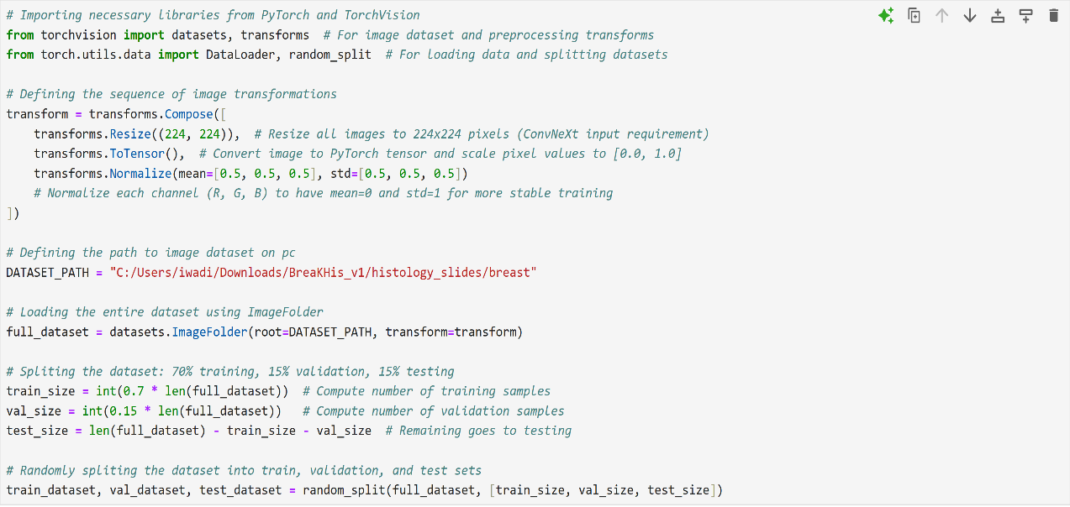
A2. Code snippet for setting up SE Attention Mechanism
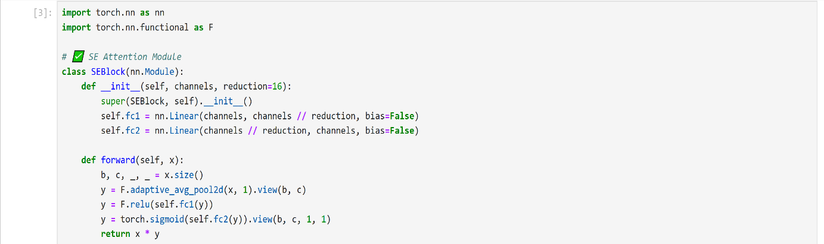
A3.Code snippet for importing ConvNeXt model
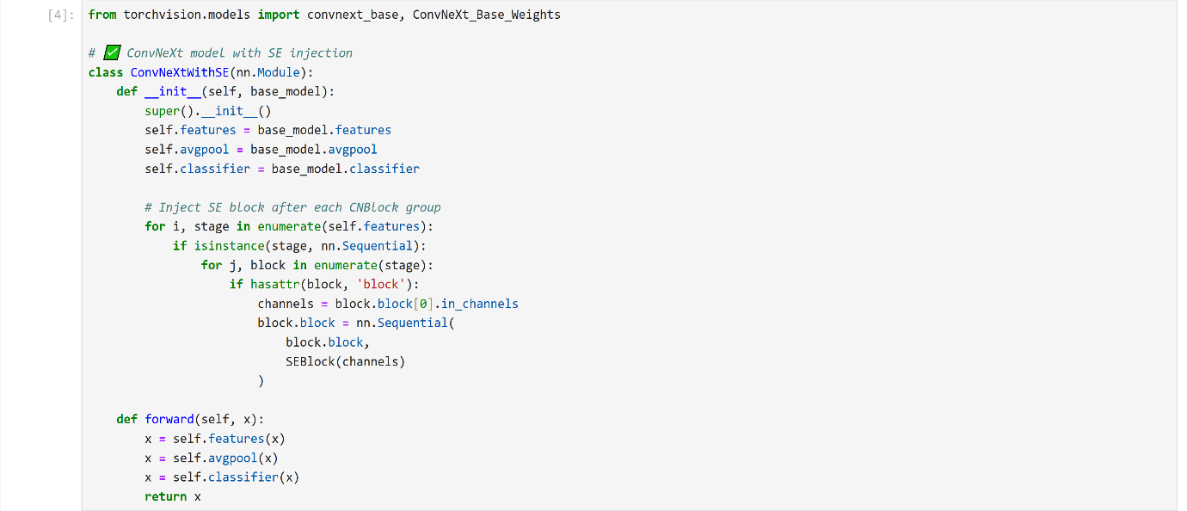

A4. Code snippet for loading the ConvNext
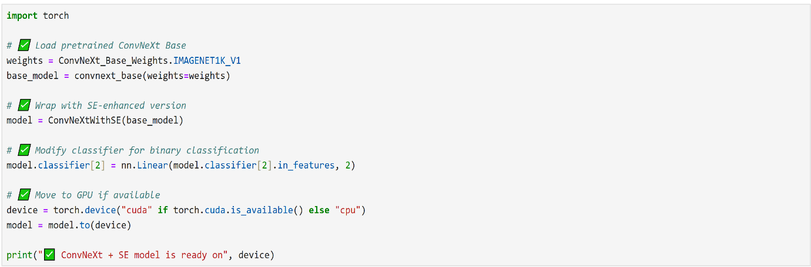
A5. Code snippet for training for the ConvNext + SE model
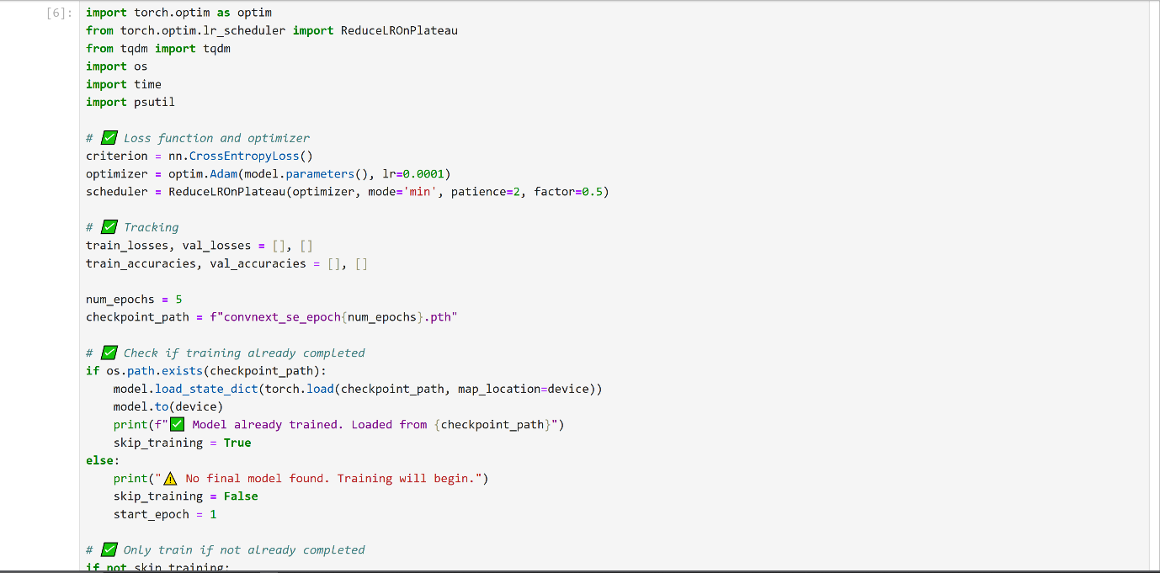
A6. Continuation of Code snippet for training for the ConvNext + SE model
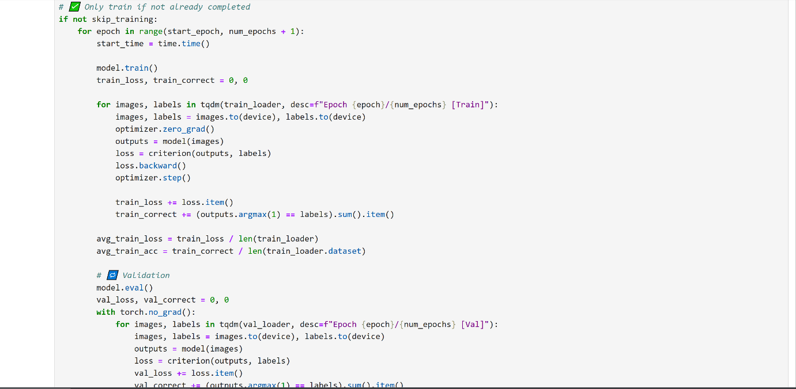
A7. Continuation of Code snippet for training for the ConvNext + SE model
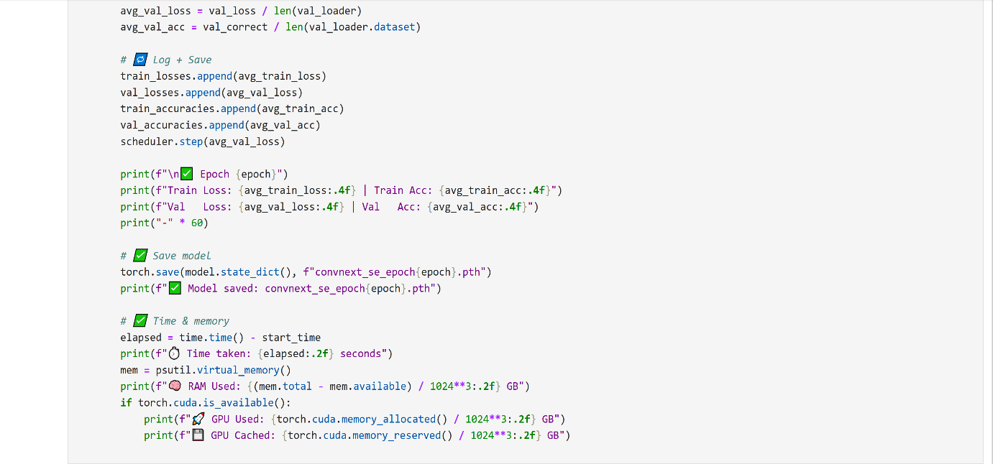
A8. Code snippet to get classification table and Confusion Matrix
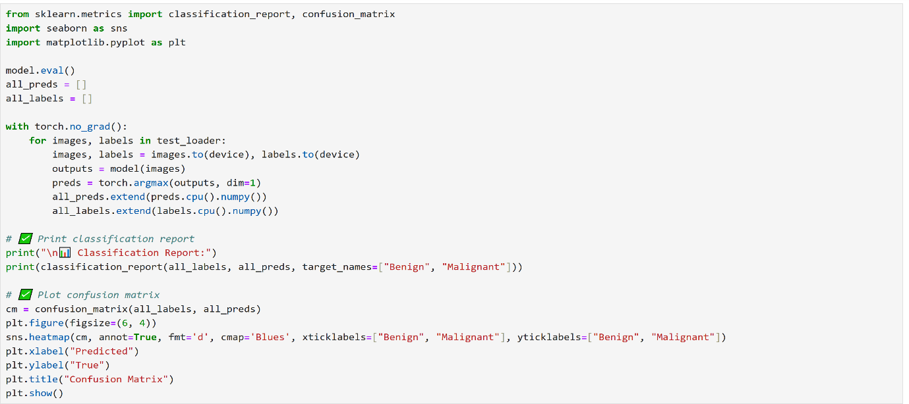
A9. Code snippet to plot Accuracy-Loss graph
